**Day 11**

**Process class 2**

**Top -** To check the running process.

**Cpu Definition**

%Cpu(s): 6.4 us, 1.5 sy, 0.0 ni, 91.6 id, 0.0 wa, 0.3 hi, 0.2 si, 0.0 st

**Us -** Amount of time the cpu spends executing the process people in user space.

**Sy -** Amount of time spent running system kernel space processes.

**Ni -** Amount of time spent executing the process with manually set nice values.

**Id -** Amount of cpu idle time.

**Wa -**Amount of time the cpu time waiting for io2 completed.

**Hi -** Amount of time for hardware interrupt.

**Si -** Amount of time spent for software interrupt.

**St** - Amount of time it takes you to run a virtual machine.

**Definition for top command to using the process**

**PID USER PR NI VIRT RES SHR S %CPU %MEM TIME+ COMMAND**

**Pid -** process id.

**User -** Owner of the process.

**Pr -** process of priority.

**Ni -** nice value of the process.

**VIRT -** The amount of virtual memory of a process.

**RES -** The amount of residential memory used by the process.

**SHR -** The amount of shared memory used by the process.

**S -** State the process.

**CPU -** The Amount the CPU consuming the process.

**MEM -** The Amount of memory consuming the process.

**TIME -** Total time used by the process.

**Command -** The command used for the process will be started.

**Command using to top**

**Shift - p =** Highest consuming of cpu

**Shift - m =** Memory use age.

**N =** Maximum tasks.

**Z =** Colour change.

**U =** View to the user.

**S =** Delay timing using.

**K =** kill the PID no to be executed.

**R =** Renice to priority pid no to priority in -20 to +19

**1.using to shift p highest consuming of cpu**

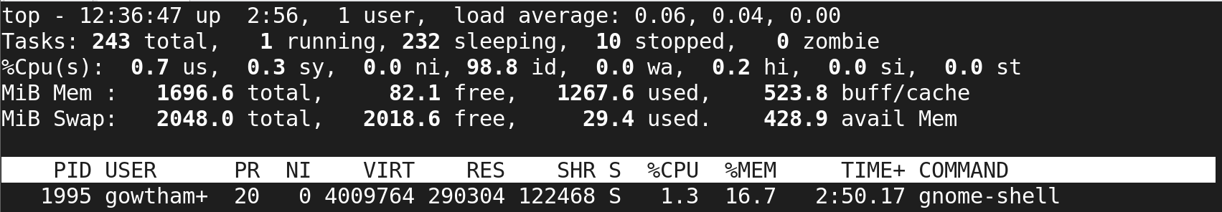

**2.using to shift m memory usage to views**

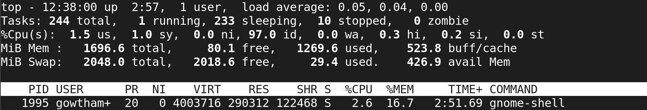

**3.using to n command to views in maximum task for 10**

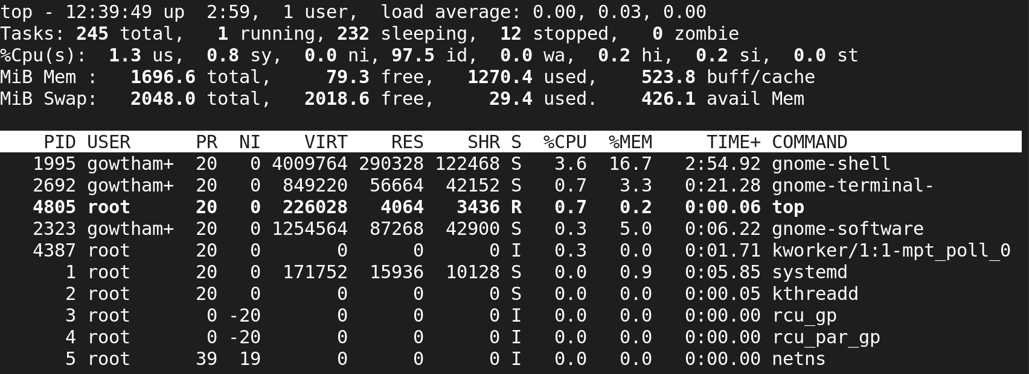

**4.using to z command to views for color in current values**

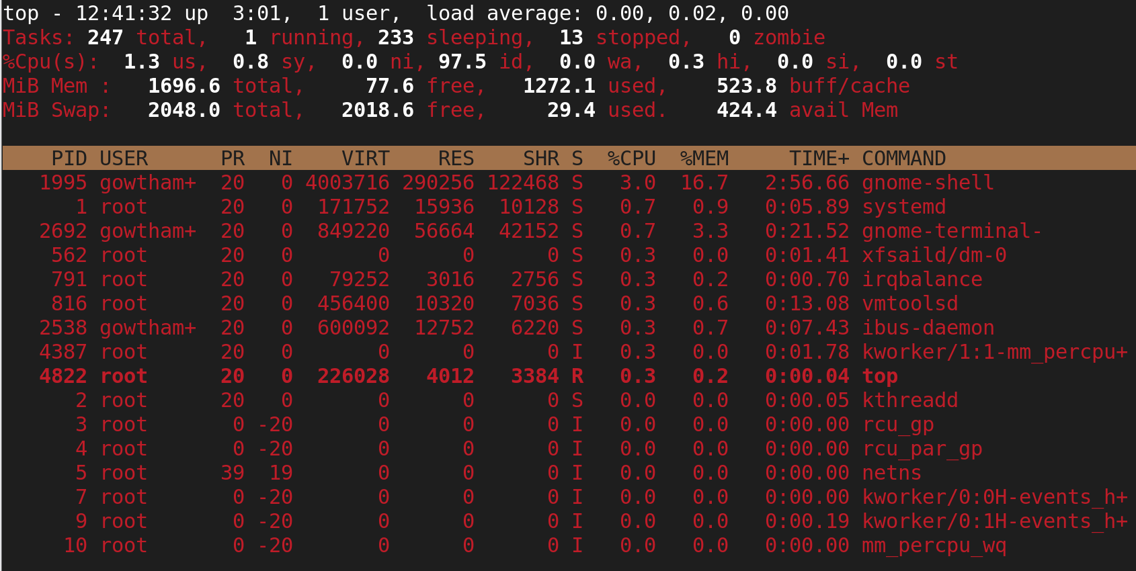

**5.using to u command views to the user**

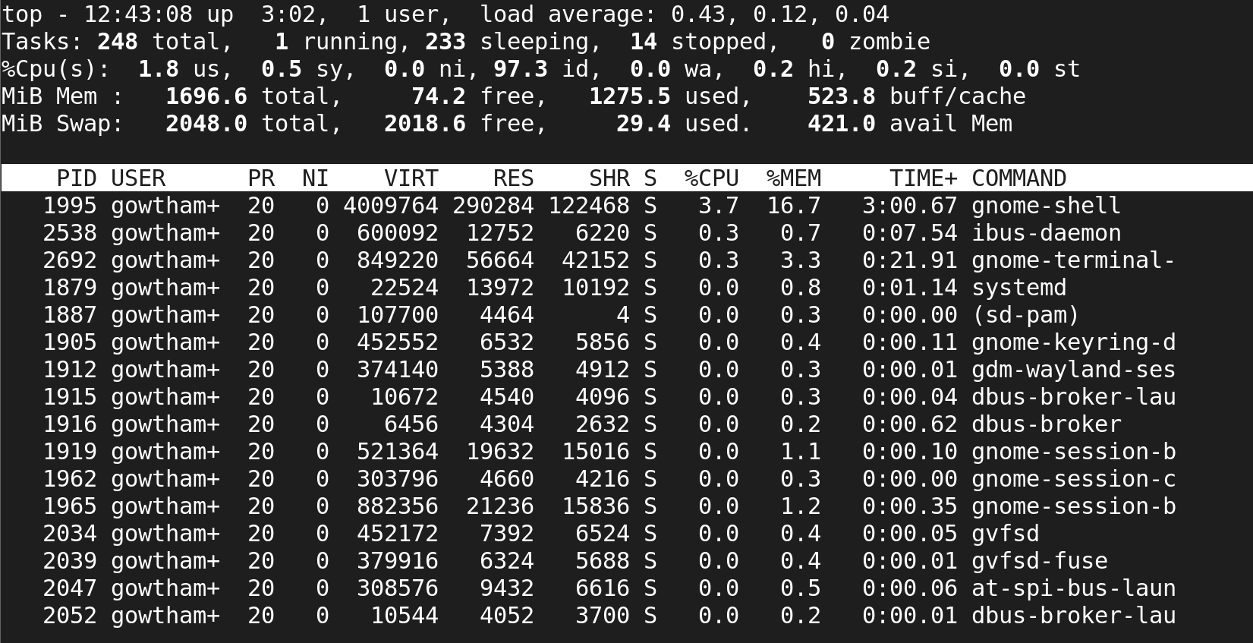

**6.using to s command delay second for views and execute to 10 sec**

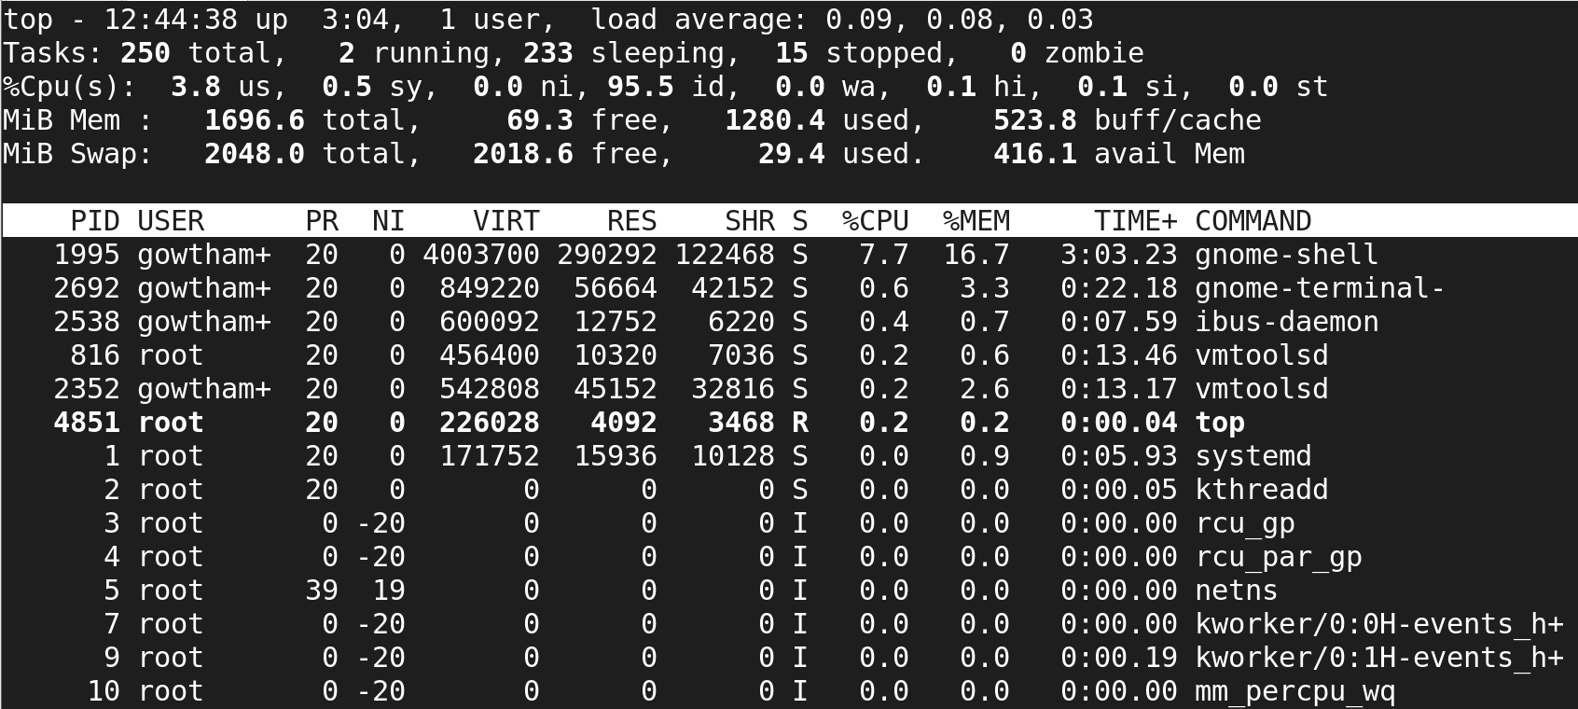

**7.using renice to priority to pid no to execute the priority in -20 to +19**

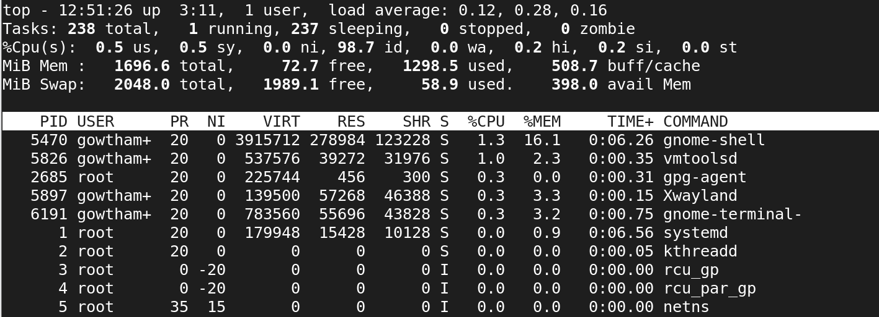

**8.using to k command to kill the pid no to execute**

